BARBARA JENSEN
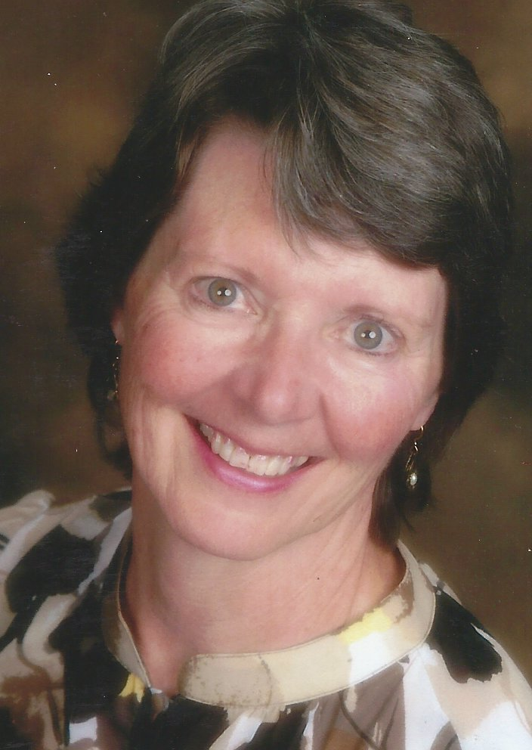

PERSONAL: Barb is married and has two grown daughters, Stacy and Kimberly, and one grandchild, Grady. She retired in 2014 from Idaho Power with 36 years of service. Barb’s BIL, Les, also retired in 2015 from Idaho Power after 35 years. Les is a pastor whose God-given passion is going on short-term mission trips. Barb and Les live in Nampa. Stacy, husband Dale, and Grady live in Caldwell, and Kimberly lives in Salt Lake City.
EDUCATION: Barb attended Boise State University and graduated with a Bachelors degree in Business Administration, Human Resources Management, in 2005. Previously she attended BSU and received a diploma in Horticulture and Landscape Design and an Associate in Business Administration.
P.E.O. Barb is a 3rd generation P.E.O. and a 41-year member. While in college, she was initiated by her mother, Margaret Vernon, into her mother’s chapter AM-Hailey. After college, she transferred to Chapter AD-Meridian, and later to Chapter BO-Boise where she’s been a member since 1986. She’s had the pleasure of bringing her sister Janice and initiating her niece Rachel into Chapter BO. In 2007, she was a delegate to International Convention in Minneapolis and served three years on the Idaho State Amendments & Recommendations Committee from 2011 – 2013. She also served a year as the Treasure Valley Reciprocity Council president from 2013-2014.
INTERESTS: Barb loves gardening, snow skiing, traveling with Les on mission trips, teaching Sunday school, hiking, exploring, camping, volunteering, and has recently taken up quilting. She mentored children at Monroe Elementary in Boise for 20 years. She and her BIL are avid BSU Bronco fans.

